19 June 2006 Dye Trace
of the Cave Farm Blind Valley
Stream Sink (MN23:B0058)

August 2006
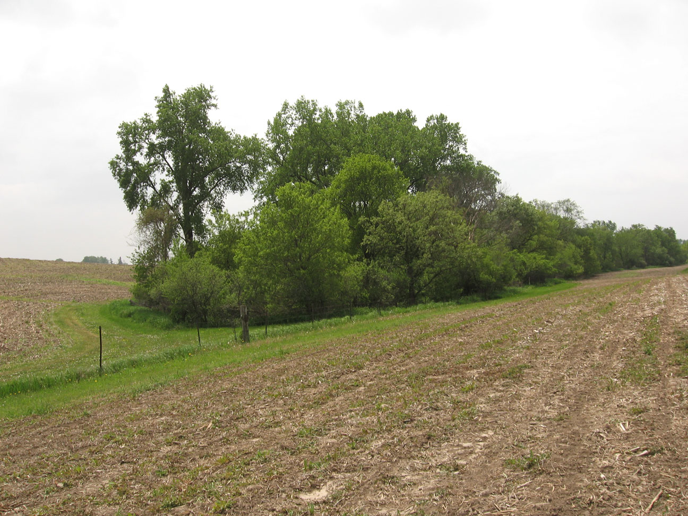
Figure 1: The Cave Farm Blind Valley, (MN23:B0058) Spring Valley, Fillmore County, Minnesota. This view is looking south at the northeast end of the blind valley.

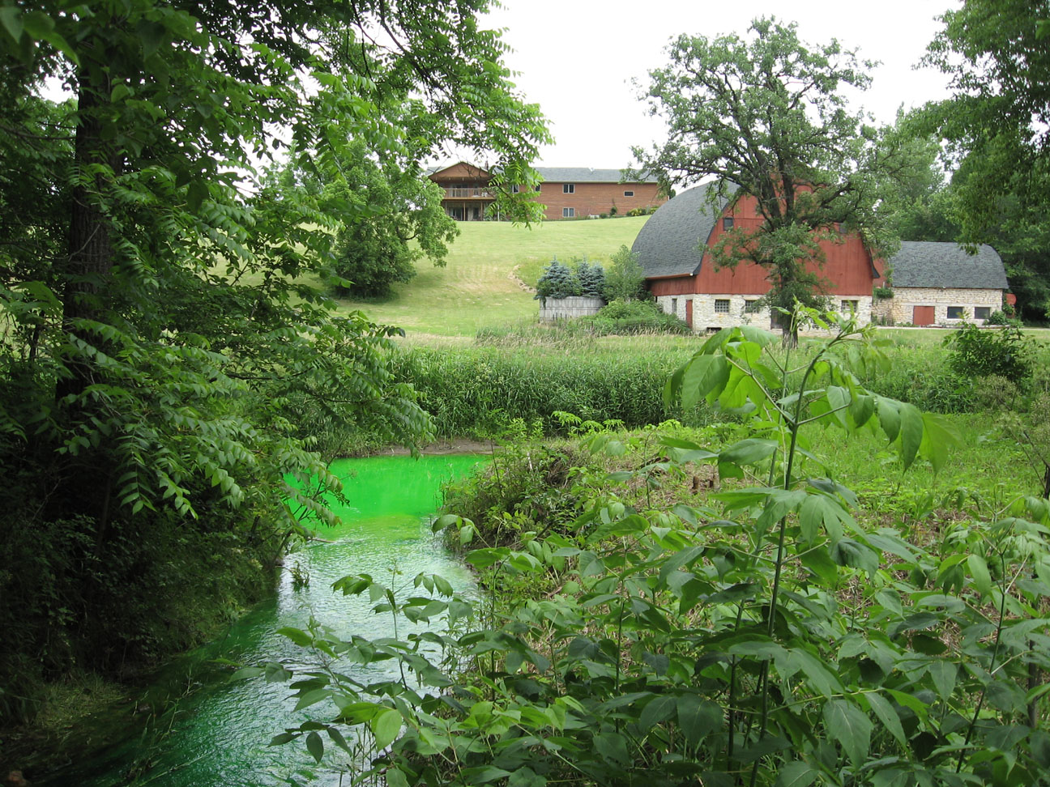

Figure 2: View north along the spring run from Bly’s Spring (MN23: A0127) toward the land owner’s home and barn. The spring run is green from the dye trace.

Daniel E. Costello∗
E. Calvin Alexander, Jr.

Department of Geology and Geophysics
University of Minnesota Twin Cities
310 Pillsbury Dr. SE
Minneapolis, MN 55455
Table of Contents
Cover 1
Table of Contents 2
List of Tables and Figures 2
Abstract 3
Introduction 3
Hydrogeologic Setting 3
Tracing Methods 6
Dye Injection 7
Dye Analyses 8
Results 8
Discussion 9
Acknowledgements 11
References 12
Appendix 13

List of Tables and Figures

Figure 1: Blind Valley MN23:B0058 on the Cave Farm, Spring Valley, Minnesota. This view is looking south at the end of the blind valley cover
Figure 2: View north from along the spring run from Bly’s Spring (MN23: A0127) toward the land owner’s home and barn. The spring run is green from the dye trace cover
Figure 3: An aerial map of the Spring Valley Caverns area showing known groundwater flow routes 4
Figure 4: Mossler and Hobbs’ (1995) block diagram of karst development on the Galena Plateau in Fillmore County 5
Figure 5: Karst distribution in southeastern Minnesota Generalized Rock Column for Southeastern Minnesota 5
Figure 6: Generalized Rock Column for Southeastern Minnesota. The Maquoketa and Dubuque formations are located in the Upper Ordovician portion (Mossler, 1995) 6
Figure 7: Dan Costello at the injection point in the Cave Farm Blind Valley, MN23:B0058 on 19 June. This stream sink is directly above a BP oil pipeline that crosses under the blind valley 8
Figure 8: Dan Costello at Bly Spring (MN23:A0127) on 22 June. The green color results from the presence of fluorescein 10
Figure 9: Updated map showing new flow route from Blind Valley (MN23:B0058) to Bly Spring (MN23:A0127) 11

Table 1: Bug Locations 7
Table 2: Summary of the results from the charcoal samplers 9

19 June 2006 Cave Farm Dye Trace of the
Blind Valley Stream Sink (MN23:B0058)

Abstract
A qualitative fluorescent dye trace has established that water sinking in the Cave Farm Blind Valley resurges at Bly’s Spring on Bear Creek in Fillmore County, Minnesota. This trace establishes the resurgence point for the Cave Farm Blind Valley and a lower limit of > 1 kilometer per day on the groundwater flow velocity. This trace documents the potential impact of a break in the British Petroleum pipeline, which is directly below the blind valley, could have on the Spring Valley karst. The Spring Valley karst also may act as an underground flow path that pirates water from Deer Creek to Bear Creek.

Introduction
A dye trace was initiated on 19 June 2006 to search for groundwater connections between the Cave Farm Blind Valley, MN23:B0058 (hereafter “B58”, the terminal stream sink in the Cave Farm Blind Valley, Figure 1 on cover) and Bear or Deer Creeks in northern Spring Valley Twp., Fillmore Co., MN. The expected resurgence spring was Bly’s Spring, MN23:A0127, (Figure 2 on cover). Figure 3 is an air photo showing the location of the Cave Farm, Spring Valley Caverns (SVC) and the results obtained in previous tracing work in the area. The Cave Farm Karst Preserve is owned by John Ackerman and more information on the Preserve is available at http://www.karstpreserve.com/svc.html.
B58 is of interest because it is the sink point for a significant surface drainage area and is directly above a British Petroleum Oil pipeline which connects the Twin Cities to a bulk petroleum product terminal located east of Spring Valley, Minnesota. The dye from two previous attempts to trace from B58 (Barry, 2003; Alexander, 2006) was not detected at any sampled location. The conditions in 2003 were very dry. The stream flowing into blind valley sank before it reached B58 and a fire truck was used to wash the dye into the ground. The conditions were much wetter at the time of Alexander’s (2006) attempted trace but he apparently used too little dye. This trace was designed to take advantage of the wet conditions and to use more dye.

Hydrogeologic Setting
The Cave Farm is located north west of Spring Valley in southeastern Minnesota in northwestern Fillmore County. The area is an active karst, containing numerous sinkholes, caves, blind valleys, and springs. The second longest cave in Minnesota, SVC, underlies the area. All of these features are parts of a pervasive underground drainage system which quickly moves surface water underground to springs along the major rivers. The presence of these features is due to the underlying carbonate bedrock, which has been differentially dissolved by rain and acidic groundwater creating subterranean flow paths, including caves. Figure 4 is a block diagram (Mossler and Hobbs, 1995) illustrating some of the relationships of these karst features. Such karst features are prominent in southeastern Minnesota where most of the glacial drift material has been eroded away, exposing the carbonate bedrock at or near the land surface. The varying levels of karst distribution in Minnesota are shown in Figure 5.

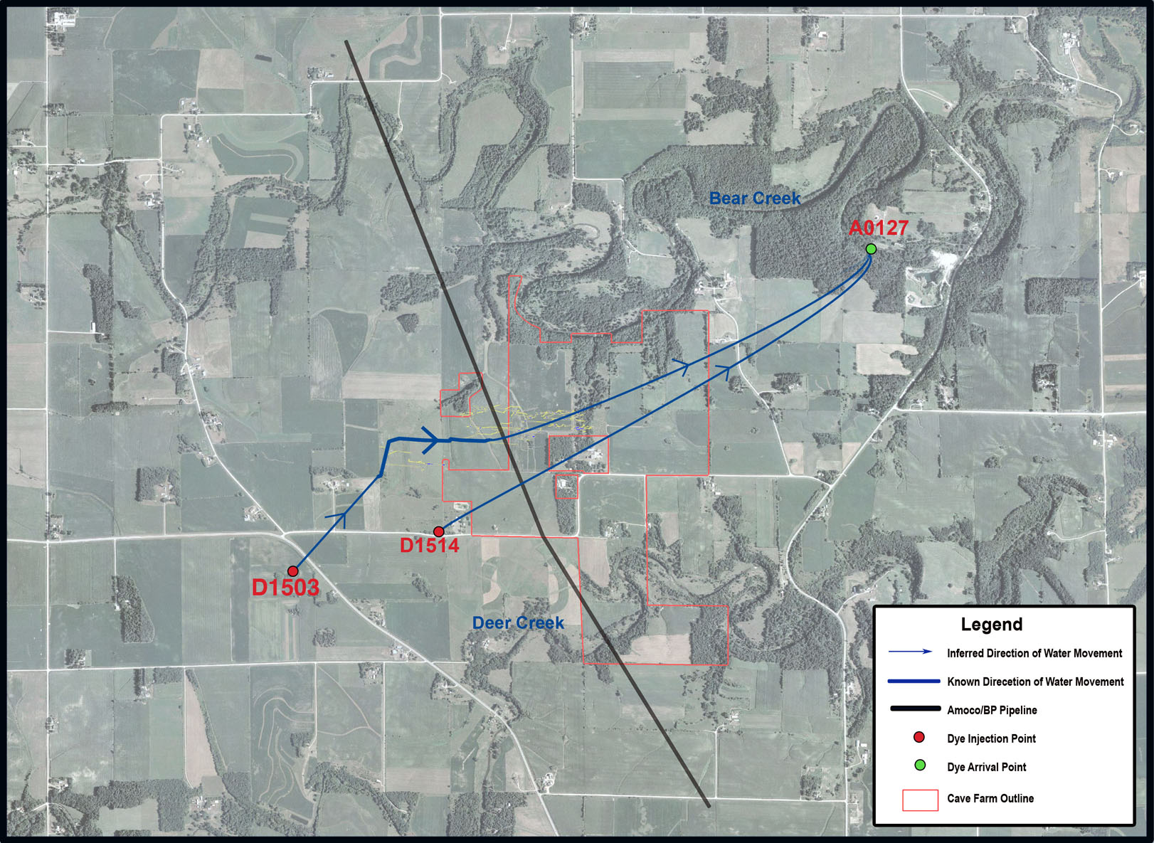
Figure 3: An aerial map of the Spring Valley Caverns area showing known groundwater flow routes.
The study area is underlain by the Maquoketa, Dubuque and Stewartville Formations, limestone units of Upper Ordovician age (Figure 6). They contain many caves and joints, both of which form as groundwater moves through the rock, dissolving carbonate and carrying it away in solution. Although the exact age of Spring Valley Caverns is not known the cave probably started forming before the Pleistocene.
Spring Valley Caverns and the other smaller caves in the area exhibit a strong joint control and appear to have started developing at the contact between the Dubuque and Stewartville Formations, probably under phreatic conditions. As the passages grew larger the migrated upward by ceiling collapse into the Dubuque and Maquoketa Formations and then eroded vadose channels down into the Stewartville Formation as the surface streams incised the landscape. Several cycles of back filling with sediment and subsequent excavation of the caves has probably occurred. The caves currently occupy a fairly flat interfluve between Bear and Dear Creeks. The groundwater flow is generally to the northeast.

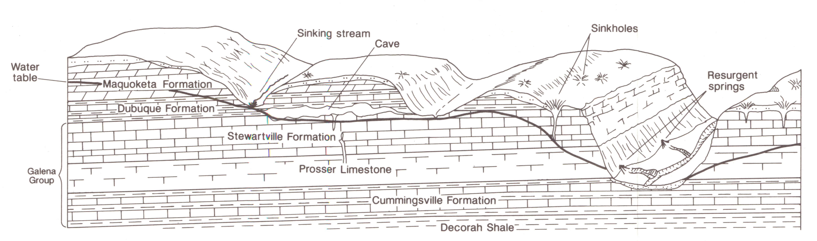

Figure 4: Mossler and Hobbs’ (1995) block diagram of karst development on the Galena Plateau in Fillmore County.

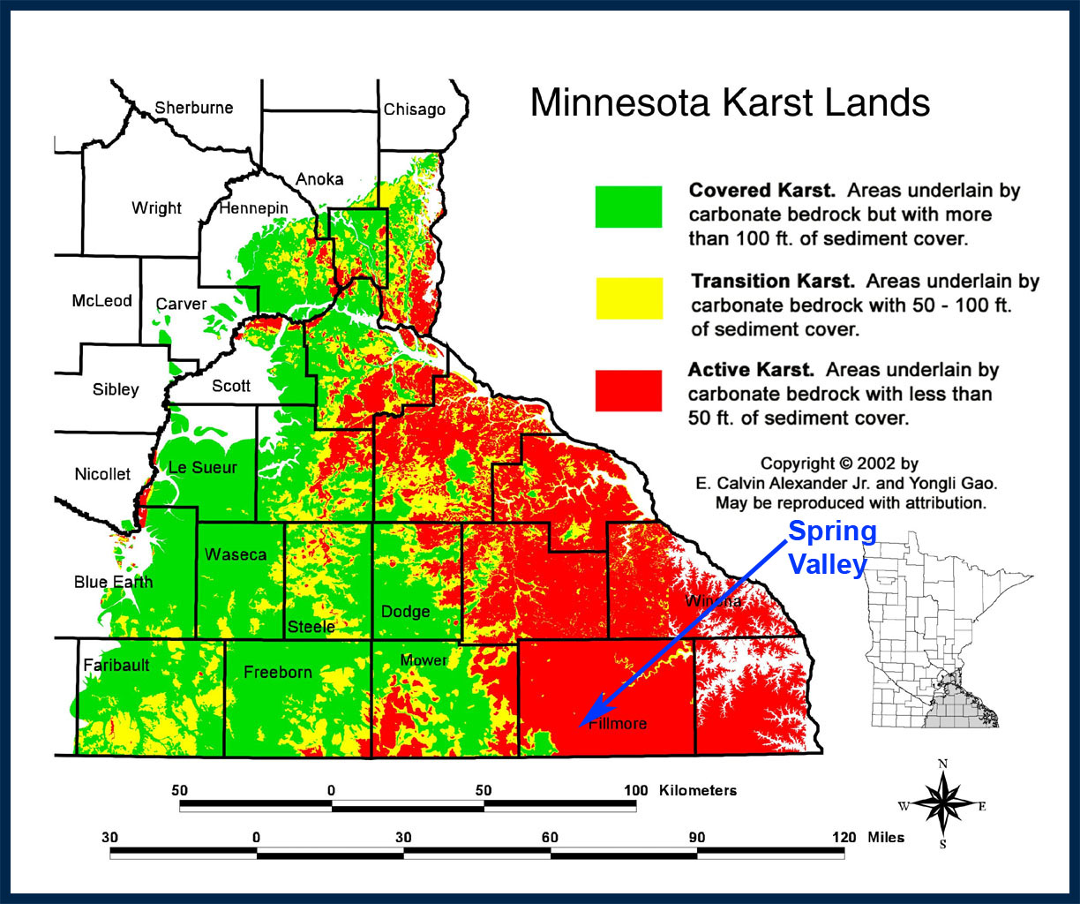
Figure 5: Karst distribution in southeastern Minnesota, showing varying levels of karst as a function of sediment cover, (Alexander and Gao, 2002).

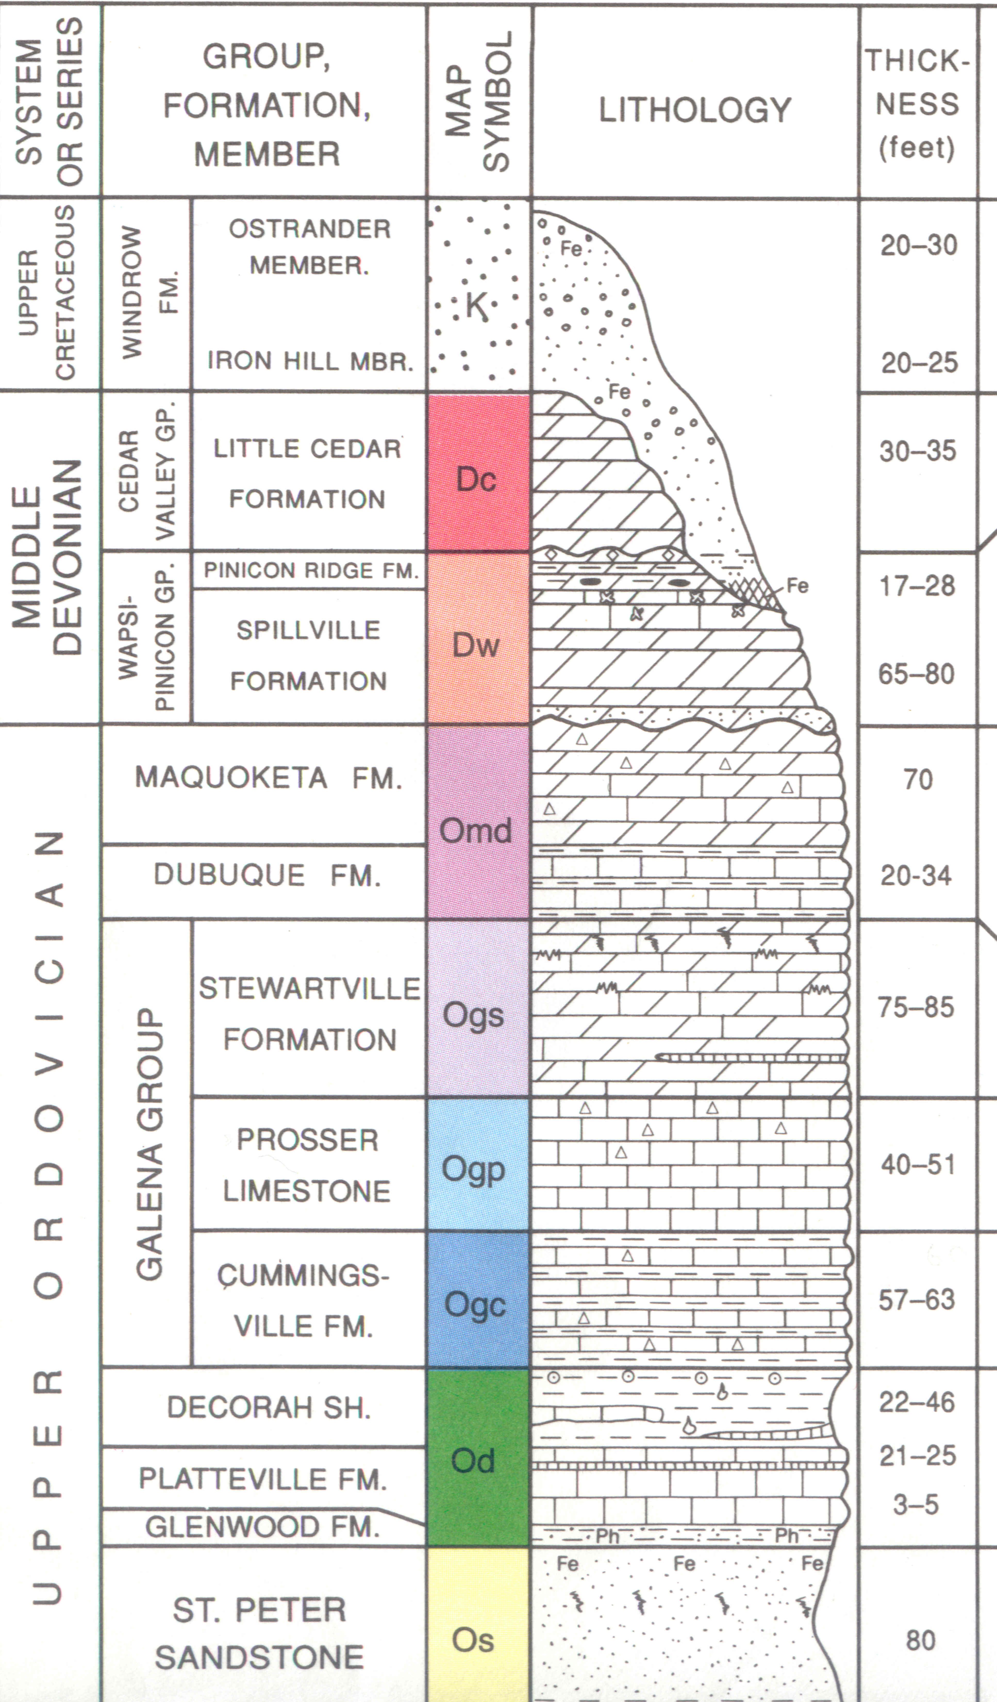
Figure 6: Generalized Rock Column for Southeastern Minnesota. The Maquoketa and Dubuque formations are located in the Upper Ordovician portion (Mossler, 1995).

Tracing Methods
The trace was conducted in a qualitative mode (Aley, 2002) using charcoal detectors (“bugs”) . Bugs were placed at a series of point in Bear Creek, Deer Creek, stream passages in Spring Valley Caverns and Bly Springs. The locations of the sampling points are shown in Table 1 and Figure 9. Those bugs were changed at roughly weekly intervals before and after the dye injection.

Table 1. Bug Locations
SVC-A, Bear Creek, Twp. Rd Bridge. Bug was hung in Bear Creek from the downstream side of the bridge in sec 6, Spring Valley Twp. 545,216 E, 4,844,472 N (± 6.7 m), UTM zone 15, NAD83, ~1223’ elevation.)
SVC-B, Bear Creek, Dead End Rd. Bug was hung in Bear Creek from the north bank immediately upstream of the old abutment at the end of the dead end road in sec 4, Spring Valley Twp. 548,233 E, 4,844,839 N (± 7.1 m), UTM zone 15, NAD83, ~1182’ elevation.)
SVC-C, Bear Creek, Lilebæltbroen Bridge. Bug was hung in Bear Creek from the downstream side of the Lilebæltbroen footbridge in sec 3 of Spring Valley Twp. 549,423 E, 4,844,926 N (± 7.9 m), UTM zone 15, NAD83, ~1106’ elevation.)
SVC-D, Bly Spring, A127. Bug was hung in the Bly Spring (MN23:A0127) below the overflow structure on the south side of Bear Creek in sec 3 of Spring Valley Twp. 549,506 E, 4,844,847 N (± 3.7 m), UTM zone 15, NAD83, ~1109’ elevation.)
SVC-E, Deer Creek, Co. 1 Bridge. Bug was hung in Deer Creek from the south bank immediately downstream of the Co. Hwy. 1 bridge in sec 9 of Spring Valley Twp. 549,078 E, 4,842,742 N, (± 3.8 m), UTM zone 15, NAD83, ~1205’ elevation.)
SVC-F, Deer Creek, Co. 8 Bridge. Bug was hung in Deer Creek under the south end of the Co. 8 Hwy. bridge in sec 17 of Spring Valley Twp. 547,177 E, 4,841,957 N, (± 4.5 m), UTM zone 15, NAD83, ~ 1239’ elevation.)
SVC-L, Bear Creek, Upstream Blind Valley Mouth. Bug was hung in the south sided of Bear Creek upstream from the continuation of the Cave Farm Blind Valley in sec 5, Spring Valley Twp. 547,086 E, 4,844,970 N, (± 4.8 m), UTM zone 15, NAD83, ~ 1196 elevation.)
SVC-M, Spring A741. Bug was placed in the spring run where it reaches the valley downstream of the Cave Farm Blind Valley in sec of Spring Valley Twp. 547,028 E, 4,844,847 N, (± 5.6 m), UTM zone 15, NAD83, ~1210’ elevation.)
SVC-N, Manggaard Spring, A742. Bug was placed in the downstream end of the spring rise pool in sec 5 of Spring Valley Twp. 547,007 E, 4,844,790 N, (± 13 m), UTM zone 15, NAD83, ~1210’ elevation.).
SVC-O, White Pine, Bear Creek. Bug was placed in the southwest side of Bear Creek in front of Bear Den cave in sec 5, of Spring Valley Twp. 547,350 E, 4,844,733 N, (± 6 m), UTM zone 15, NAD83, ~1189’ elevation.)
SVC-P, Bear Creek, SVC Ravine. Bug was placed in the south side of Bear Creek, at the mouth of the SVC ravine, in sec 4 of Spring Valley Twp. 547,718 E, 4,844,381 N, (± 12 m), UTM zone 15, NAD83, elevation

Dye Injection:
3.28 kg of fluorescein dye was dissolved in the sinking stream water and was poured into the terminal sink of the Cave Farm Blind Valley MN23:B0058 in the SW¼ of the SE¼ of section 5, Spring Valley Twp. (T103N, R13W), Fillmore Co., MN at 17:00 PM CDT, 19 June 2006. 546,965 E, 4,844,067 N (Zone 15, NAD83), ~1250 ft elevation, Maquoketa/Dubuque Formations.

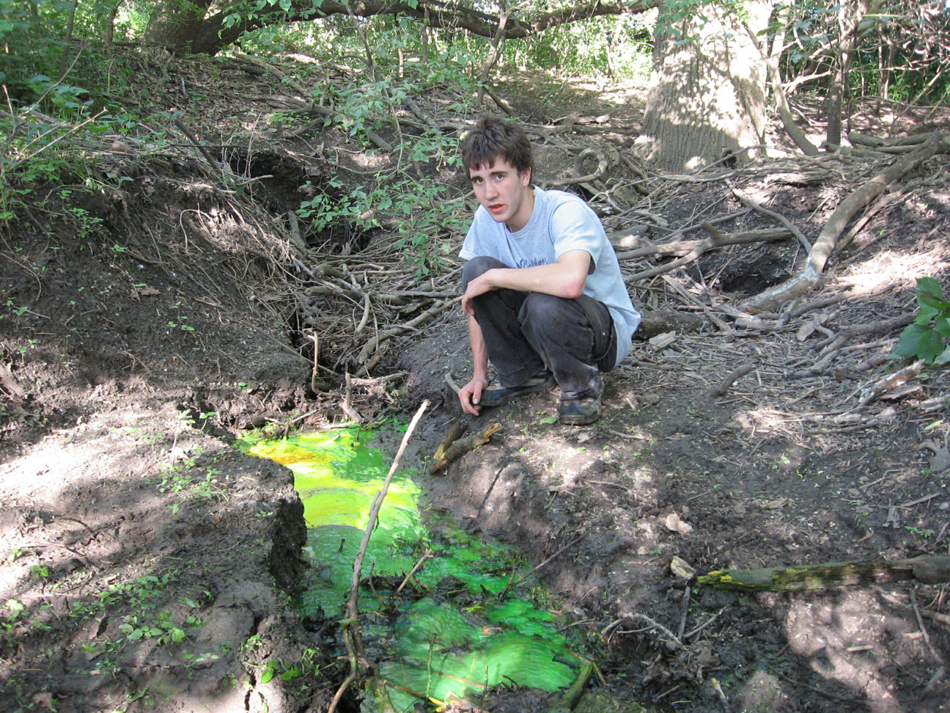

Figure 7: Dan Costello at the injection point in the Cave Farm Blind Valley, MN23:B0058 on 19 June. This stream sink is directly above a BP oil pipeline that crosses under the blind valley.

Dye Analyses:

The charcoal detectors were collected and returned to the Hydrogeochemistry Lab of the Geology & Geophysics Department of the University of Minnesota for analysis. The detectors were opened, charcoal removed, the fluorescent materials were stripped from the charcoal with basic isopropyl alcohol and analyzed in a scanning spectrofluorophotometer. The spectra were recorded digitally and PeakFit was used to quantify the individual spectral components. The methods used are described by Alexander (2005).

Results:

The fitted spectra as included in the appendix and the results are summarized in Table 2.

Table 2. Summary of the results from the charcoal samplers.

Station | 19 Jun | 22 Jun | 28 Jun | 6 Jul
SVC-A | nd² | nd² | nd² | nd²
SVC-B | nd² | nd² | nd² | nd²
SVC-C | nd² | nd² | nd² | nd²
SVC-D | nd² | fluor | fluor | fluor
SVC-E | nd² | nd² | nd² | nd²
SVC-F | nd² | nd² | nd² | nd²
SVC-L | fluor¹ | nd² | nd² | nd²
SVC-M | fluor¹ | nd² | bl³ | bl³
SVC-N | fluor¹ | nd² | nd² | nd²
SVC-O | --- | nd² | nd² | bl³
SVC-P | nd² | nd² | nd² | nd²

Table Notes: set = charcoal detector installed, nd² = no dye detected, --- = charcoal detector not changed, fluor = fluorescein dye detected, bl = bug lost.
¹ Small traces of fluorescein are present in charcoal detectors SVC-L, SVC-M, and SVC-N exchanged on 19 June before fluorescein was poured into B58. These are taken to be cases of inadvertent contamination of these three bug, probably in the field or during transportation to or from the field on 19 June.
³ On 6 July the SVC-M and SVC-O charcoal detectors were found with the milk sock torn and charcoal removed. This is most likely the result of an animal tearing the bag open and charcoal being lost into the river.

Discussion:
The fluorescein that was injected into the terminal sink of the Cave Farm Blind Valley MN23:B0058 was detected at MN23:A0127, Bly’s Spring, the Lost River Rise. When the bugs were changed on 22 June, the first time after the dye injection, Bly’s Spring was visibly positive for fluorescein (Figure 8). That observation constrains the flow time to be less than 2.8 days. Bly’s Spring is 2.8 km east northeast of the dye input point. The flow velocity is therefore greater than 1 km/day.
The dye was not found in any other charcoal detectors, so the exact path of flow is not known. A diagrammatic path connecting the input point and Bly’s Spring is shown in Figure 9. The overall path of the water from B0058 to Bly’s spring was roughly east northeast. This third attempted dye trace from B58 produced the first positive results, probably due to the wet conditions and the use of more dye.
Stream sink B58 is important because it is directly above a buried Amoco/British Petroleum pipeline. The pipeline was constructed in the 1950s and connects the Twin Cities with the BP Terminal just east of Spring Valley, Minnesota. The pipeline’s age and its location across several major passages in SVC has long concerned SVC’s owner. The potential damage of a pipeline leak to the SVC area is enormous.

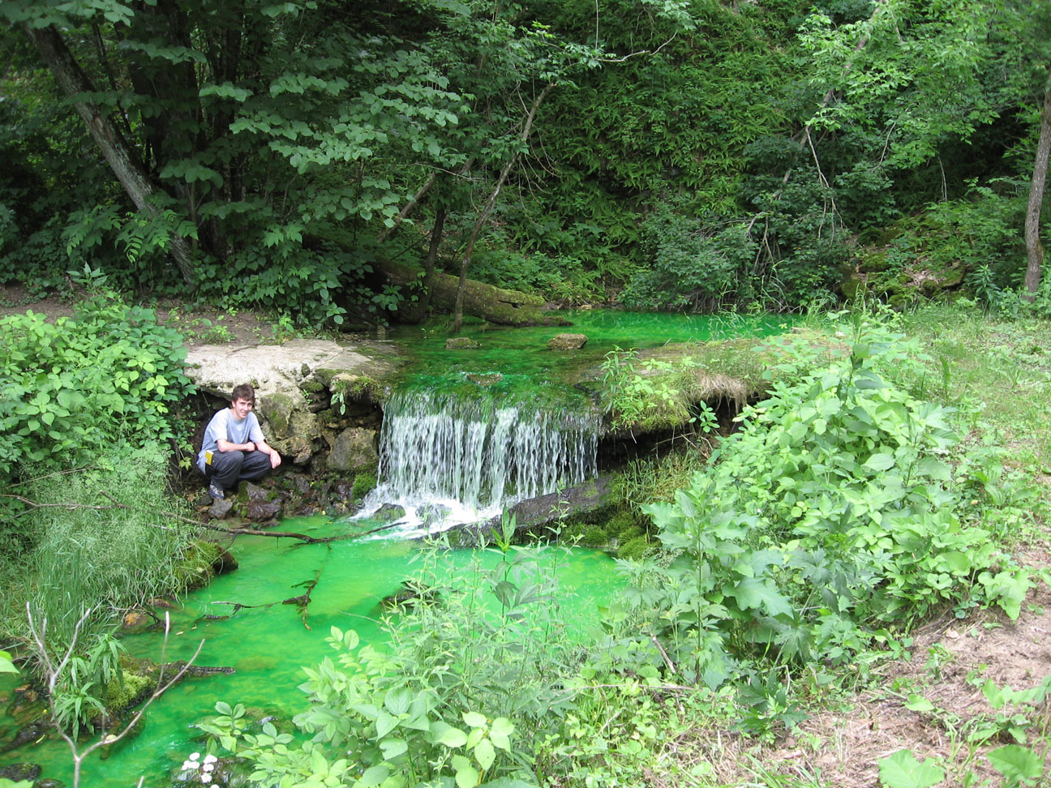
Figure 8: Dan Costello at Bly Spring (MN23:A0127) about noon on 22 June. The green color results from the presence of fluorescein.

This result extends the known extent of the drainage basin feeding Bly’s spring about ¼ mile to the north. Our results correlate with previous dye traces in the SVC area to show that groundwater flow is predominately northeast. A testable, working hypothesis is that SVC acts as an underground connection between Deer Creek to the south and Bear Creek to the north, i.e. that SVC is pirating water from the Deer Creek drainage to the Bear Creek drainage (Barry, 2003). In order to test this hypothesis, additional dye traces could be run from areas closer to Deer Creek, in order to extend the known drainage basin area to the south.

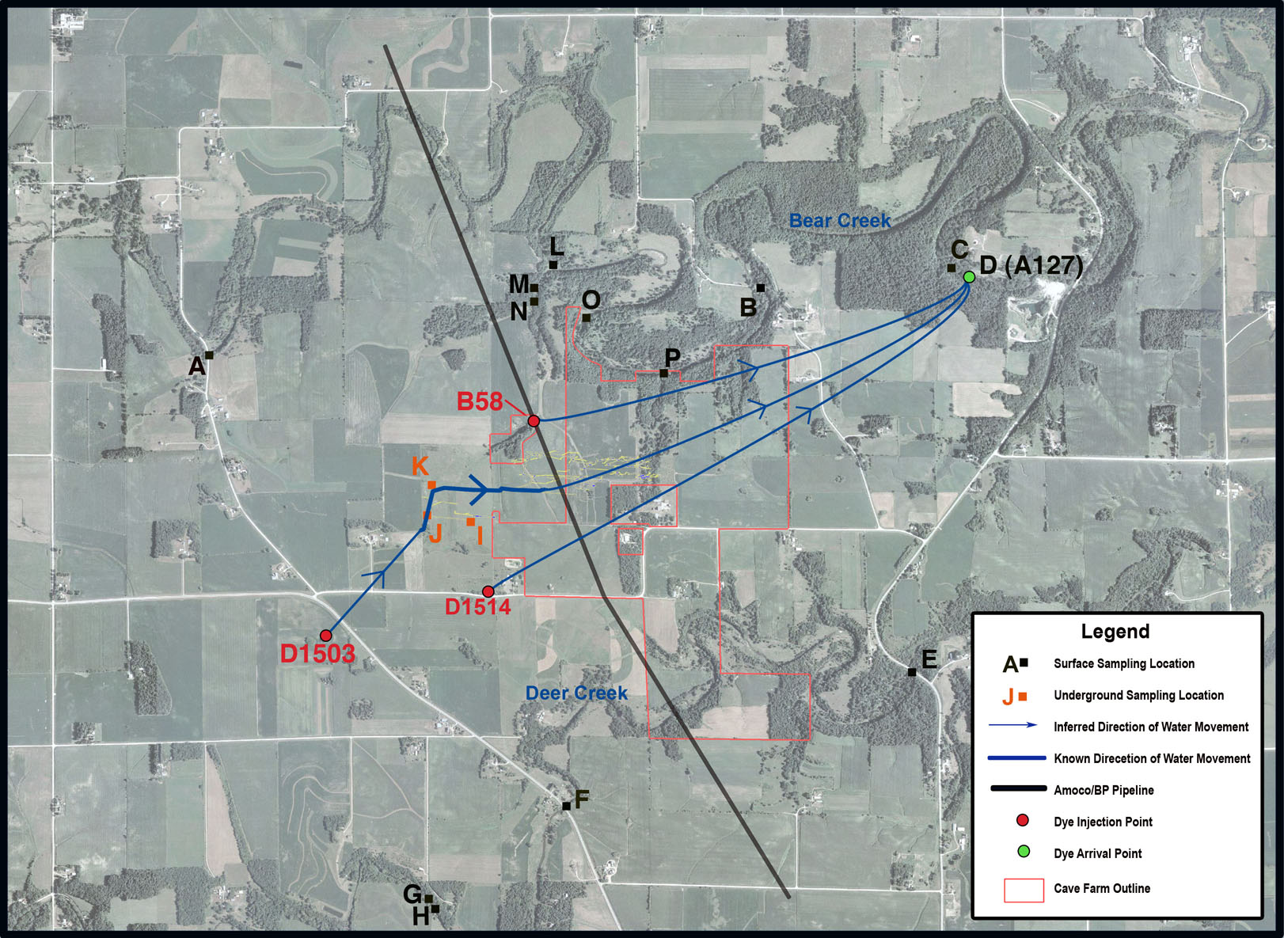

Figure 9: Updated map showing new flow route from Blind Valley (MN23:B0058) to Bly Spring (MN23:A0127). Sampling locations are also noted.

Acknowledgments:
First thanks are due to John Ackerman for conceiving and establishing the Cave Farm. It is a wonderful place to conduct this type of investigation. Scott Alexander plays many, varied but always critical roles in this work. Too many different individuals helped with the various field aspects of this effort for us to list them all accurately. We appreciate all of those efforts.

References:
Alexander, Scott C. (2005) Spectral Deconvolution and Quantification of Natural Organic Material and Flourescent Tracer Dyes. In: ( Barry F. Beck, ed.) Sinkholes and the Engineering and Environmental Impacts of Karst, Geotechnical Special Publication No. 144, ASCE, Reston VA, p. 441-448.
Alexander, E. Calvin, Jr. (2006) 20 May 2006 SVC Dye Trace, unpublished report, 6 p. + appendix.
Alexander, E. Calvin, Jr. and Yongli Gao (2002) Minnesota Karst Lands. Copyrighted image. Reprinted with permission.
Aley, Thomas (2002) Groundwater Tracing Handbook. Ozark Underground Laboratory, Protem, MO, 35 pp.
Barry, John, (2003) Subterranean Conduit Flow in the Spring Valley Caverns Region, Fillmore County, Minnesota, PowerPoint presentation prepared for Geo 5713, December 2003, 24 slides.
Mossler, John H. (1995) Bedrock Geology, Plate 2, Geologic Atlas Fillmore County, Minnesota, County Atlas Series, Atlas C-8, Part A, Minnesota Geological Survey, St. Paul Minnesota.
Mossler, John H. and Howard C. Hobbs (1995) Depth to Bedrock and Bedrock Topography. Plate 4, Geologic Atlas Fillmore County, Minnesota, County Atlas Series, Atlas C-8, Part A, Minnesota Geological Survey, St. Paul Minnesota.

Appendix

Dye Analysis Spectra

 Current address: Geology Department, St. Norbert College, 100 Grant St., De Pere, WI 54115.

